Questionnaire

to explore the polar observational needs of the

weather, sea ice, and climate prediction communities

Background

KEPLER is an initiative built around the operational European Ice Services and Copernicus services to prepare a roadmap for Copernicus to deliver an improved European capacity for monitoring and forecasting the Polar Regions. KEPLER aims at assessing the polar observational needs of the weather, ocean, sea ice, land, and climate prediction and research communities, and how this need is expected to develop over the next 10 years and beyond. The outcomes of KEPLER will be used by the European Commission to help guide the development of its Earth monitoring program: the Copernicus Services, and to help develop future research funding calls related to the polar observing system.

By answering this questionnaire you and/or the institution you represent can have your say in these strategic considerations for the future evolution of the polar observing system and services.

The questionnaire targets intermediate users of polar observations. Intermediate users are defined as those who use observational data to produce value-added products (“information”) that are used either by end-users directly, or by further downstream intermediate users. Intermediate users are thus at the same time information/service providers (Figure 1).

The questionnaire is intended not to be too specific, so that most of the questions should apply to different kinds of intermediate users/providers (including for example NWP centres, national ice services, Copernicus services, as well as climate research centres). If you find that one or the other question is not relevant for you and your centre/institution, please feel free to omit answering it.

The questionnaire aims to tap your expertise regarding two different types of needs, namely (i) the downstream user needs you are trying to address as provider of products and (ii) your own polar observational needs resulting from the former.
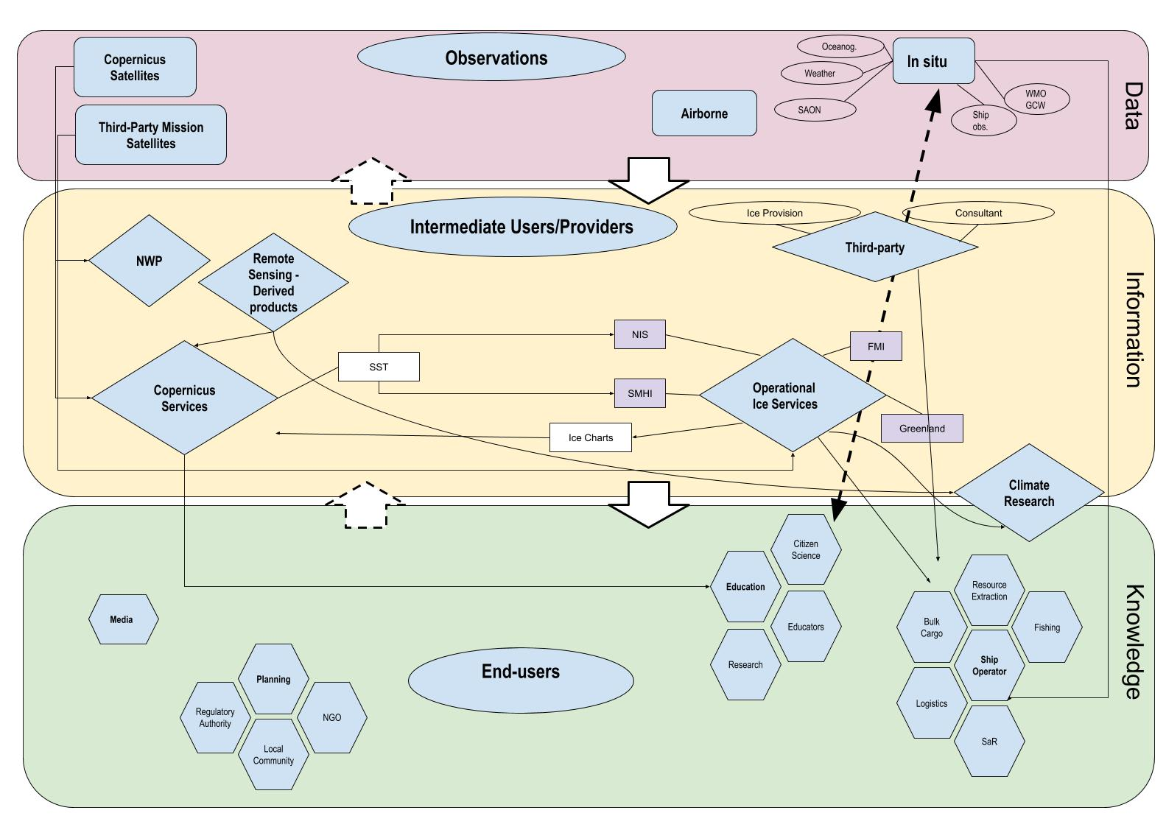
Figure 1: The “user-scape” of polar observations. This questionnaire targets Intermediate Users/Providers, those groups assembled in the yellow middle box. Note that specific groups and links are exemplary.

When answering the questions, please consider any aspects that appear most relevant to you. The questions are intentionally relatively broad and not multiple-choice based so that you can focus on points that you consider important. However, where applicable, you might also consider the following attributes:
- Which parameters (e.g. ice-edge location, ice pressure, ice concentration, temperature, winds/gusts, visibility, wave height, snow water equivalent, permafrost, river discharge, biological production, etc.) are needed?
- What resolution is required (in space and time)?
- In case of forecasts, which range is of highest interest (hours, days, months, years)?
- Is timeliness/latency an issue for you?
- Is the method of delivery appropriate?
- Is the quality of existing data sufficient / which accuracy is needed?
- Are explicit uncertainty estimates required and/or (if already contained in existing products) reliable in your experience?
- Are existing products sufficiently well documented?

It has been a conscious decision to organise this questionnaire as a text document instead of using an online survey tool. This way we hope to facilitate the sharing of the questionnaire including draft answers with your colleagues so that you can work jointly toward a set of answers more representative of your institution or group of colleagues.

Please return the filled questionnaire via email to Helge Goessling (helge.goessling@awi.de) before July 5th 2019; if you need more time, please let us know. If questions related to the answering of the questionnaire arise, please feel free to ask your KEPLER contact person at any time. Your support is highly appreciated!

Questionnaire

Please remember to consider the attributes mentioned above in the bulleted list where appropriate in your answers.

Question 1: What is the general mission of your institution, in what sense are you intermediate users of polar observations, and which services/products are you offering? How important are polar observations to enable your service provision?

Answer:

Question 2: What are the most important needs of users that you are already addressing with your services/products, and which polar observations are these based upon? Conversely, what are the most important needs of your users that you are not able to meet?

Answer:

Question 3: Which future products/services you are currently working on and planning to provide within the next 5-10 years? Which existing and/or upcoming polar observations will these be based upon?

Answer:

Question 4: The definitions of the terms "near-time time” (NRT) and "high-resolution" vary between users depending on whether this is for tactical and navigation, planning or climatological usage. What is your understanding of these two specific terms and how do you define them?

Answer:

Question 5: How do you expect the needs of downstream users to develop in the foreseeable future, and how does that translate into requirements toward the polar observing system for your institution?

Answer:

Question 6: Regarding Figure 1, we would like to illustrate how different users interact and exchange data or information. Depending on who the user is, it is not always linear and can be lateral. For example, Copernicus Services use raw data from satellites, as do Ice Services who also sometimes used derived products from the Copernicus Services (e.g. SST). Can you identify where there are more links between different users?

Answer:

Question 7: Do you have additional advice, independent of immediate user needs, how the polar observing system shall be developed to enable better forecasts (and thus ultimately enhanced services and products)?

Answer:

Question 8: Could you please provide any documentation or publications, such as outcomes of earlier requirement surveys related to polar observational needs, that we should take into account?

Answer:

The subsequent information will be treated confidentially.

Your name(s):

Your institution:

Your email address:

